**Network of Food Recipes**

**Introduction:**

After studying discrete math we are now capable to draw graphs for analysis purposes. The objective of our graph is to observe the use of various ingredients in different recipes. We obtained two different graphs after converting the initially obtained bipartite graph into unipartite.

*The first graph has ingredients as vertices and the edge between two ingredients shows that they were used in the same recipe.*

*The second graph has recipes as vertices and the edge between two recipes shows that they have some ingredients in common.*

**Data Source:**

*Book of Recipes from pupils of Grangetown Primary School and St Paul’s Church of Wales Primary School, Grangetown, Cardiff, Wales.*

Although our data source is not local but the recipes are quite similar to our local recipes.

|  |  |  |  |  |  |
| --- | --- | --- | --- | --- | --- |
| **For Graph 1 (nodes=ingrdients)** | | | | | |
| **Nodes** | **Edges** | **Avg degree** | **Diameter** | **Clustering** | **Top 5 nodes** |
| 63 | 310 | 9.8 | 5 | 0.8302 | Onion, salt, greenchilli ,Potatoes ,egg. |

|  |  |  |  |  |  |
| --- | --- | --- | --- | --- | --- |
| **For Graph 2 (nodes=recipes)** | | | | | |
| **Nodes** | **Edges** | **Avg degree** | **Diameter** | **Clustering** | **Top 5 nodes** |
| 16 | 44 | 5.5 | 5 | 0.596 | PotatoPakora,BaltiChicken,RootVegetableBiryani,Banglay,CarrotandCorrianderSoup |

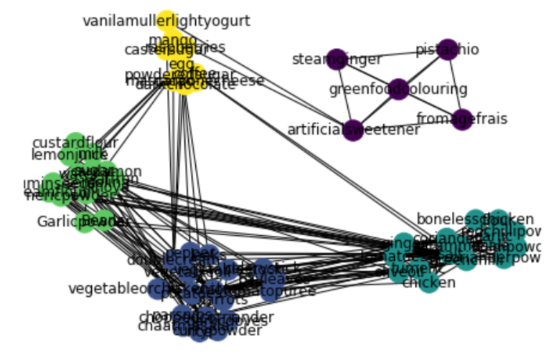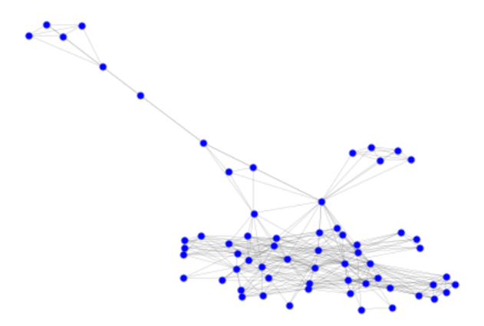

Figure 1

Graph 1

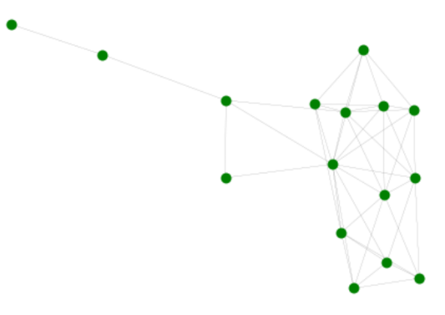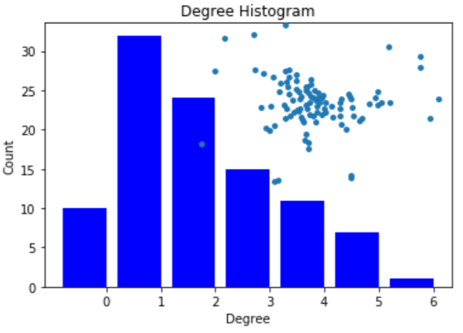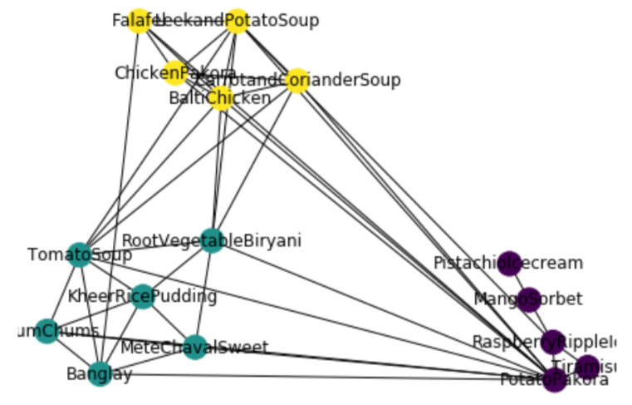

Figure 2

Graph 2

The visualization above shown in the figure 1 shows the different group of ingredients used in different types of recipes. E.g the yellow nodes are the ingredients used to prepare deserts. Similarly Blue nodes are the ingredients used to prepare different kind of soups.

The visualization shown in figure 2 shows three different group of recipes. The same color nodes represent recipes of same type. E.g the green color nodes are recipes which are spicy in taste, yellow color represents recipes of different soups and the purple color shows recipes of different icecreams.